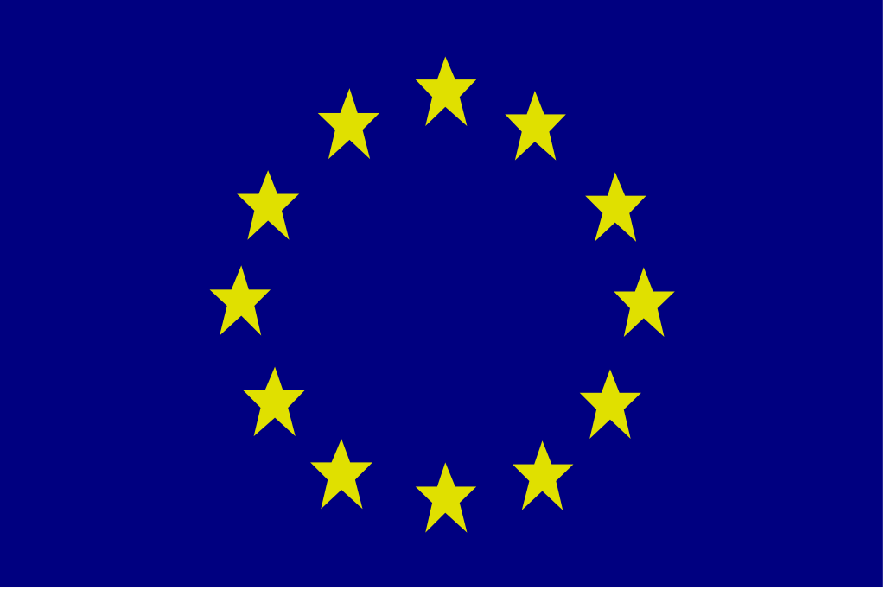

Statement on behalf of the European Union and its Member States
By

at the Security Council Open Debate on

"Trafficking in Persons in Conflict Situations"

United Nations

New York
21 November 2017

Mr President, Excellencies, distinguished participants, ladies and gentlemen,

I have the honour of speaking on behalf of the European Union and its Member States.

Alignment para…………………………..

I thank the Secretary-General Antonio Guterres, Executive Director Fedotov, and Special Rapporteur Giammarinaro for their statements.

We would like to congratulate Italy for convening this debate and commend their keen commitment to address the issue of trafficking in human beings in conflict.

Today's debate, and the adoption of the resolution, is an important contribution to the fight against trafficking in conflict situations, building on the momentum created by Resolution 2331 (2016). The EU is strongly committed to the implementation of both Resolution 2331 and the resolution adopted today.

We also stand behind the Political Declaration on the implementation of the United Nations Global Plan of Action to Combat Trafficking in Person, adopted by the General Assembly at the High Level Meeting in September.

Mr President,

Trafficking in human beings is a threat to human and national security alike - to peace, human rights, democratic governance and the rule of law.

Trafficking in human beings is also a grave violation of human dignity, and it is specifically prohibited in Article 5(3) of the Charter of Fundamental Rights of the European Union. It is a form of serious, transnational organised crime and it has huge human, social and economic costs. It is driven by demand for all forms of exploitation and by very high profits, in both the legal and illegal economies, resulting in a complex interplay between supply and demand that must be addressed if the crime is to be eradicated.

We know that trafficking in the context of conflict takes many forms, including trafficking for the purposes of sexual exploitation and for the purposes of forced labour. And we also know that vulnerability to trafficking is heightened in the context of conflict, and that victims are all too often subjected to horrific crimes of sexual violence. Special attention should be paid to the protection of children who are particularly vulnerable to trafficking, especially in conflict situations.

Mr President,

We welcome the Report of the Secretary-General on trafficking in persons in armed conflict pursuant to Security Council resolution 2331 (2016). The report highlights the prevalence of the problem in a number of specific conflict situations, but also sets out many positive steps that have been taken by Member States and UN agencies, including efforts to better implement legal instruments; to better identify, protect and assist victims; and to improve data collection and the tracking of financial flows. The EU welcomes these efforts and the recommendations set out in the report.

We reiterate our support for the recommendations in the report submitted by the Secretary-General in April 2017 on conflict-related sexual violence, including on the need to continue to address the nexus between trafficking in persons and conflict-related sexual violence, including by terrorist groups.

Mr President,

By upholding and promoting international standards, as enshrined in the United Nations Convention against Transnational Organised Crime and its Protocols; the Convention on the Elimination of all Forms of Discrimination Against Women; the Rome Statute of the International Criminal Court, and other international legal instruments, we contribute to ensuring strong foundations for the rule of law. We must renew and invigorate our efforts to implement the existing legal architecture.
Mr President,

The EU has built an ambitious and comprehensive legal and policy framework to combat trafficking in persons. The EU approach is human rights-based, victim-centred, gender-specific and child-sensitive. It focuses on prevention, prosecution of criminals and protection of victims, taking into account the specific assistance needs of the most vulnerable and especially women and children, who form the vast majority of those trafficked. In this regard, the EU has promoted national mechanisms for early identification and assistance of victims based on the principle of non-punishment and unconditional assistance.

Anti-Trafficking actions also form a key part of our external policies and funding, and we are committed to the comprehensive achievement of the 2030 Agenda, including targets 5.2, 8.7 and 16.2.

In September, the European Union and the United Nations launched a new partnership, the Spotlight Initiative, to eliminate all forms of violence against women and girls, backed by an initial dedicated financial envelope of €500 million. This initiative will focus on all forms of violence against women and girls, including trafficking in human beings and sexual and economic exploitation.

The EU will also work towards ensuring the implementation of the commitments made under the Call to Action on Protection from Gender-Based Violence in Emergencies, including dedicating humanitarian aid to supporting the prevention of, and response to, gender-based violence.

We work closely with UNODC, IOM and many other UN agencies via joint programmes across the globe, and will continue our cooperation. Bearing in mind that trafficking is a development issue, a peace and security issue, and a human rights issue, we call for greater coherence across the UN and stress the role of the Inter Agency Coordination Group against Trafficking in Persons (ICAT). ICAT has an essential role to play in ensuring that efforts across the UN system are coherent and avoid duplication.

The European Union naval operation EUNAVFOR MED Operation Sophia, working under a mandate from the Security Council, continues to disrupt traffickers’ networks and bring smugglers to justice, while rescuing many thousands of persons in the southern central Mediterranean.

Mr President,

There is a market for the trafficked human "merchandise", including those trafficked in the context of conflict. We need to investigate, prosecute and convict the perpetrators of these crimes and we need to put an end their impunity. Prevention must remain central to all actions against trafficking in human beings. Effectively preventing this heinous crime necessitates reducing demand.

The European Commission will shortly publish its priority actions to address trafficking in human beings. These will build on the ongoing work, taking stock of the achievements of the EU strategy 2012-2016 and ensuring the continuation of efforts, including coordination with stakeholders, increasing the knowledge base and victim protection.

It is imperative that all authorities and stakeholders strengthen their work on prevention by untangling the complex chain of trafficking, reducing demand, following the money and ensuring better access to justice for the victims. Strengthening cooperation among countries of origin, transit and destination is paramount to preventing, detecting and addressing this scourge, by identifying its routes and dismantling its networks and markets. And we must work with the private sector and on our own public procurement to ensure that supply chains are free of trafficking.

Finally, just as the Security Council has recognised that trafficking can drive conflict, we should also recognise that our efforts to combat trafficking can contribute to peacebuilding and sustaining peace.

Mr President,

As we continue the fight against trafficking in human beings inside the European Union, we will maintain and enhance our cooperation with our international partners with the goal of eradicating trafficking in all countries, including those experiencing conflict.

Thank you.

